- Tên và phân loại:

- Mục đích, ý nghĩa:
- Provide an interface for creating families of related/dependent objects without specifying their concrete classes
- Động lực sử dụng:
- A GUI is typically built using a toolkit of widgets (windows, menus, scrollbars etc.). Different toolkits, for example OSF/Motif and PM, define different look-and-feels.
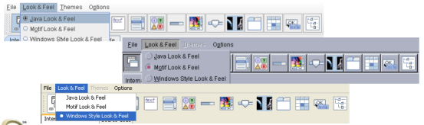
- Khi nào sử dụng:
- A system should be independent of how its products are created, composed, and represented.
- A system should be configured with one of multiple families of products.
- A family of related product objects is designed to be used together, and you need to enforce this constraint.
- You want to provide a class library of products, and you want to reveal just their interfaces, not their implementations.
- Cấu trúc
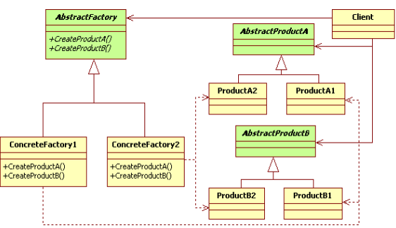
- Các thành viên - Sự cộng tác
- AbstractFactory: Declares an interface for operations that create abstract product objects
- ConcreteFactory: Implements the operations to create concrete product objects
- AbstractProduct: Declares an interface for a type of product object
- ConcreteProduct: Defines a product object to be created by the corresponding concrete
factory
- Client: Uses only interfaces declared by AbstractFactory and AbstractProduct Classes
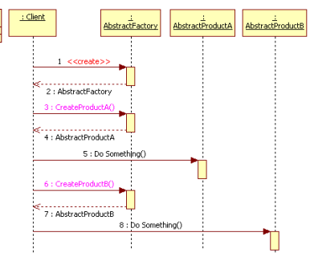
- Các hệ quả mang lại:
- It isolates concrete classes
• Helps you control the classes of objects that an application creates
• Isolates clients from implementation classes (because a factory
encapsulates the responsibility and the process of creating product
objects)
• Clients manipulate instances through their abstract interfaces
• Product class names are isolated in the implementation of the concrete
factory; they do not appear in client code
- Makes exchanging product families easy
• Concrete factory class appears only once in an application – that is,
where it's instantiated ➔ makes it easy to change the concrete factory an
application uses
• Can use different product configurations simply by changing the
concrete factory (because an abstract factory creates a complete family
of products, the whole product family changes at once)
- Promotes consistency among products
• When product objects in a family are designed to work together, it's
important that an application use objects from only one family at a time.
AbstractFactory makes this easy to enforce.
- Supporting new kinds of products is difficult
• Extending abstract factories to produce new kinds of Products isn't easy
(because the AbstractFactory interface fixes the set of products that can
be created)
• Supporting new kinds of products requires extending the factory interface,
which involves changing the AbstractFactory class and all of its
subclasses.
- Chú ý liên quan đến cài đặt:
- Hệ thống thực tế

- Mẫu liên quan
- Abstract Factory classes are often implemented with
• Factory Methods
• Prototypes
- A concrete factory is often a Singleton

